ROSCOE COLLEGIATE HS/P-TECH ACADEMY
2022 – 2023
MASTER SCHEDULE
INTERVENTION AND TUTORING SCHEDULE

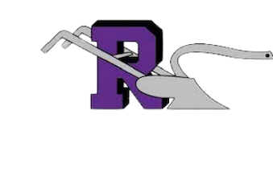

All RCHS students have multiple opportunities each week of the 2022 -2023 academic school year to gain individual and small group intervention outside of the designated classroom. These opportunities are available through student request and teacher required request. The students will be required to attend teacher assigned tutorial dates day/evening/Saturday school assignment. All student enrolled in a Western Texas College or Texas State Technical College course who’s grade falls below a 75 will be assigned to at a minimum one evening tutorial or Saturday tutorial session.

*RCHS faculty will send all missed or incomplete assignments to the tutorial monitor for evening and Saturday tutorials. Students are able to be dismissed when all assigned work is completed.

