ROSCOE COLLEGIATE HS/P-TECH ACADEMY TESTING DATES 2022 – 2023

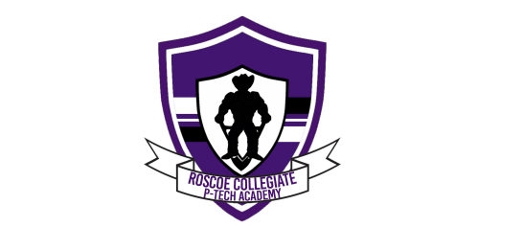
PSAT/SAT/TSI TESTING DATES | TSI/TSIA  March 2023: All  8th grade students will be TSI tested in Reading/Writing/Math  (PAA must be Complete)
PSAT | 2022 – 2023: 9th – 12th grade students who are not TSIA complete in one or more testing areas will be tested throughout the year until TSIA complete. RCHS is a TSIA testing center and students may test upon testing readiness. Specific Testing dates: Jan. 13, 2023, Feb. 10, 2023, March 31st, 2023 (Students may request to take a test on other days. There must be a 2 - 3 week tutoring time before a retake will be given.)
Wednesday, October 12, 2022/11th Grade  Wednesday, October 26, 2022/ 9th Grade | TSIA Summer Bridge Camps  June 2023: 8th grade students who are not TSIA complete will attend a TSIA Summer Bridge Camp.
SAT  https://collegereadiness.collegeboard.org/sat/register/dates-deadlines | June 2023: 9th – 11th grade students who are not yet TSIA complete in all areas will attend a Summer Bridge Camp
Wednesday, October 12, 2022  RCHS SAT testing date for all 12th grade students | *Specific camp sites and dates will be set in early Spring 2023.
ACT

https://www.act.org/
Thursday, March 9, 2022
RCHS ACT testing date for all 11th grade students

