Roscoe Montessori
Early Childhood Center
Campus Improvement Plan
2025-2026

Roscoe Collegiate Montessori Early Childhood Center

Roscoe ECC SBDM Committee 2025-2026
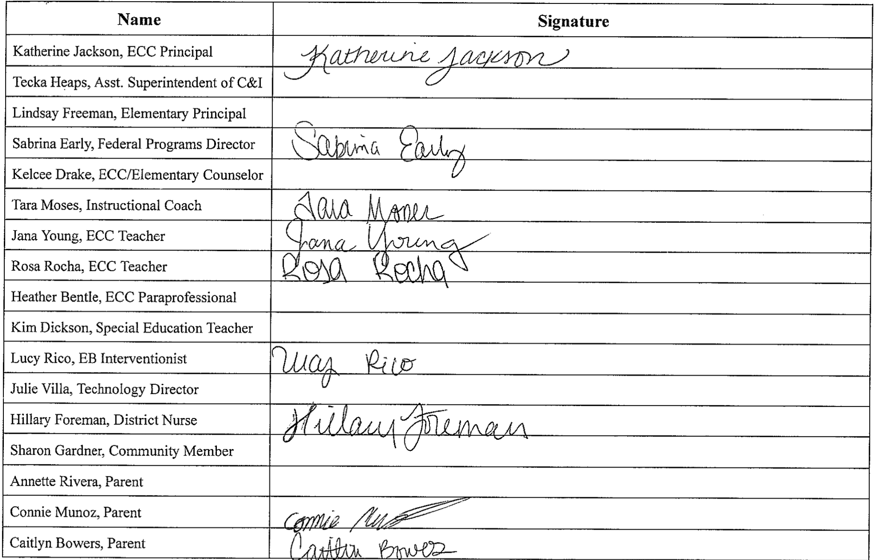

School Board Members Signature Page
2025-2026

District Mission Statement

The goal of the Roscoe Collegiate P-20 System Model for Student Success is to develop a collaborative,
sustainable and replicable model for breaking the generational poverty cycle through higher education (EARLY
COLLEGE) while supplying critical agricultural STEM workforce shortage areas that will be critical to
meeting the daunting challenge of feeding and clothing nine billion people on the planet by 2050. Roscoe
Collegiate ISD is responsible for preparing its students to meet the challenges that they will face in tomorrow’s
world. It is our responsibility to: “Produce productive, active, and social members for society.”

Vision Mission Statement

To nurture confident, curious, and capable young learners who are prepared for their education through a foundation of respect, discovery, and joy in learning.

Campus Mission Statement

At the Early Childhood Center (ECC), we believe that early childhood education lays the foundation for lifelong learning and the betterment of society, as inspired by Dr. Maria Montessori. Our community of educators, families, and young learners works together to create a safe, nurturing, and enriching environment where every child is valued and empowered to reach their full potential.

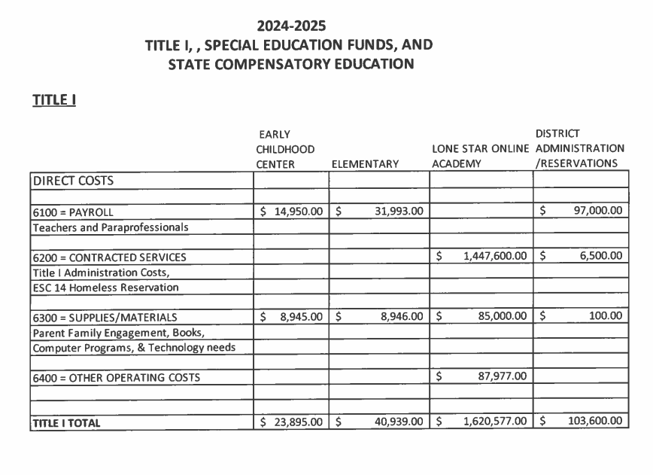

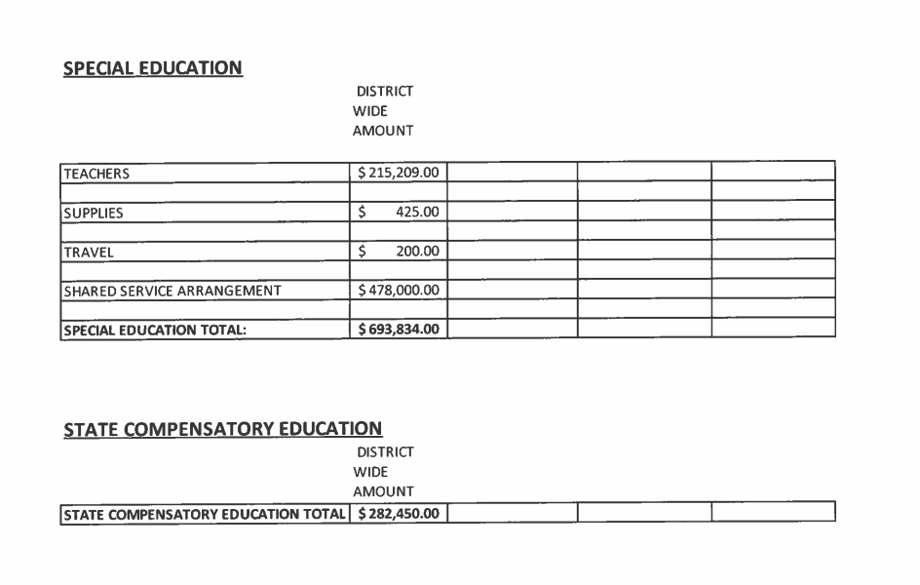

Narrative
The Roscoe Collegiate Montessori Early Childhood Center (ECC) serves students three to six years of age for preschool and kindergarten. Roscoe CISD serves a predominantly economically disadvantaged population. The Early Childhood Center is 45% economically disadvantaged.
Roscoe is mostly made up of two ethnic groups – Hispanic and White. 54 percent of the students served are Hispanic, 42 percent of the students served are White, and one percent is Asian, with the remaining three percent being multicultural. Approximately 45 percent of the students at the Early Childhood Campus are eligible for free or reduced-price lunches under the National School Lunch program and four percent are limited English proficient (LEP).
Roscoe Collegiate Montessori Early Childhood Center meets the needs of the students with highly certified teachers and highly qualified paraprofessionals who obtain professional development through the regional service centers, professional development in Montessori through appropriately developed programs, and attend conferences for pre-kindergarten and kindergarten teachers in the summer. All teachers receive training in strategies, initiatives, and activities to carry out the campus plan. The district leadership team decides and approves staff development with the guidance of the Campus Site Based Decision Making Committee.
Roscoe Collegiate Montessori Early Childhood Center has many opportunities for all students to meet state proficiency on district and state assessments. Special programs continue to serve special populations in the school. These programs include Title I, Emergent Bilingual (EB), Counseling, Dyslexia, Gifted and Talented, 504, Homeless, Occupational and Physical Therapy, Vision Therapy, Speech Therapy, and Intervention Services. Special Education Response to Intervention and Child Find are in place to ensure that students are appropriately referred to the special education program. Effective timely additional assistance is available to all students experiencing difficulty and in need of extra assistance through the help of interventionists and instructional coaches.
Parents are encouraged to be involved in the education of their children. Parents are invited to Title I Meetings, Meet the Teacher nights, Parent Information Nights, Open House, Book Fair, Pop Tarts with Pals, Fall Festival, Biscuits and Books, parent conferences, annual track meet, field trips, our annual Easter Egg Hunt, our annual Thanksgiving Meal, Daddy/Daughter dance, Mother/Son Dance, and various other activities. Parents are invited and welcome to eat lunch with their children after a six week normalization period. Parents are encouraged to meet with teachers, to communicate via Remind, phone, email, monthly signature pages, and the campus Facebook account, as well as directly with the Early Childhood faculty and staff. First six weeks report cards, beginning of year NWEA MAP and CLI Circle reports, and parent/teacher compacts are gone over in a parent teacher conference at the conclusion of the first six weeks of school. Parents are solicited for feedback on the needs of their children through parent conferences and online surveys. Parents also participate in committees to create and evaluate the campus plan, parent and family engagement policy, and teacher-parent-student compacts. Other parental and community involvement opportunities on our campus include Roscoe Readers and the Teacher Appreciation Group.
The development of this plan was directed by the campus principal with the assistance of the campus Site-Based Decision Making committee. All stakeholders have input through their representatives to the committee and direct contact with the principal. Members of the committee include grade level teachers, administrators, counselors, instructional coaches, paraprofessionals, special program coordinators, parents, and community members.

The following describes the demographics of our student population in September 2025.
Total student population: Montessori Early Childhood - 85 (as of September 2025)
Ethnicity Number % of Total
Multicultural 2 2.41%
African American 0 0%
Hispanic 45 54.22%
White 35 42.17%
Native American 0 0%
Asian 1 1.20%

Special Populations
Eco. Disadvantaged 37 44.58%
Emergent Bilingual (EB) 3 3.61%
Migrant 0 0%
At-Risk 3 3.61%
Special Education 4 4.82%
Gifted & Talented 0 0%

Roscoe ISD is in a shared service arrangement with WTCSSA that operates the special education program.
Roscoe Early Childhood Center is proud to note that our students are served by a combination of experienced and novice teachers. Our staff includes one teacher having over 50 years of experience, three teachers with 6-20 years of experience, and one teacher with 3-5 years of experience.

Comprehensive Needs Assessment Summary
2025-2026

Utilized Data Sources:
TAPR, Attendance Data, PEIMS - Student Demographics, HR - Staff Experience & Demographics, Teacher Appreciation Group activity, CNA: CKH Family Surveys, Staff Surveys, Parent Teacher Conference Data, Technology Inventory & use, T-TESS data, PEIMS - Discipline Referrals, Social Media & Remind Engagement, Financial Data, Staff Professional Development Records, 2024-2025 CIP, Content Based Assessment data, MAP data, TX-KEA data, Circle Progress Monitoring data, and Disaggregated Student Assessment Data.

Area Reviewed | Summary of Strengths  What were the identified strengths? | Summary of Needs  What were the identified needs? | Priorities  What are the priorities for the campus, including how federal and state program funds will be used?
Academic Achievement | Weekly PLCs  Data PLCs every six weeks  Montessori Method of Instruction  Kindergarten math and reading blocks  Work plans  Team lesson planning and lesson pacing  Early detection of reading deficits in Kindergarten students.  Kindergarten - Reading Content Based Assessments (CBA) White sub pop scored an average of 87%.  Kindergarten - Math Content Based Assessments (CBA) All sub pop averaged 82%, White sub pop averaged 85%, and Hispanic sub pop averaged 80%.  EOY PK Circle Math - White sup pop scored 93% and Emergent Bilingual sub pop scored 100%. | Kindergarten - Reading Content Based Assessments (CBA) All sub pop scored an average of 76%, the ECD sub pop scored an average of 74%, Hispanic sub pop scored an average of 71%, and the EB sub pop scored an average of 37%.  Kindergarten - Math Content Based Assessments (CBA) ECD sub pop averaged 79% and EB sup pop averaged 59%.  EOY PK Circle Math - All sub pop scored 83% and Hispanic sub pop scored 75%.  EOY PK Vocabulary - All sub pop scored 72%, White sub pop scored 79%, Hispanic sub pop scored 70%, and ECD sub pop scored 65%.  Emergent Bilingual (EB) English Language Instruction for EB students.  Handwriting curriculum with verbal prompts implementation aligned through 3rd grade.  Professional development for teachers in best practices for instruction of Emergent Bilingual (EB) students.  Bluebonnet Math curriculum  IXL implementation for math and reading | Kindergarten reading will continue to be an intense focus this year. We will retain our classroom paraprofessionals to allow teachers to work one on one and with small groups for more explicit, systematic ELAR instruction. Title I funds will be utilized for paraprofessional salaries.  Emergent Bilingual student growth in both math and reading, specifically vocabulary  Low socioeconomic student growth in both math in reading  PD for best practices for Emergent Bilingual students  PD for best practices for preschool students  Parent Nights on How to Help Your Child Succeed in School focused on stressing the importance of English language acquisition, routines, procedures, and follow through, and stressing the importance of early literacy.  Handwriting curriculum with verbal prompts implementation  Bluebonnet Math curriculum and support from Region 14 to assist in the process.  Savvas science curriculum continued implementation
Staff Quality | All staff are highly qualified or considered highly qualified through our DOI plan.  Five out of five teachers were retained from last year. Four teachers with more than five years experience.  Lead teacher with more than 15 years Early Childhood experience and training.  All staff trained in YMHFA.  All teachers trained in Capturing Kids Hearts.  Highly qualified paraprofessionals in every classroom.  Weekly PLCs  Four teachers have completed Reading & Math Academies.  Team lesson planning and data analysis.  Attendance of summer PD focused on PK-K research based practices, TEKS, and PK Guidelines.  Continued T-TESS implementation  Vertical alignment meetings with Elementary campus this school year.  One TIA Exemplary teacher for our campus.  One TIA Mastered teacher for our campus. | Vertical alignment meetings K-3rd with Elementary campus.  Paraprofessionals trained in Capturing Kids Hearts. | Highly Qualified Paraprofessionals  Professional Development Opportunities  Vertical Alignment
School Climate/Safe and Healthy Schools | Montessori Peace Education & Grace and Courtesy  National Showcase Campus Recognition for Capturing Kids Hearts Implementation  Crisis Go  Visitor Management System  Final Site/Parent Link | Continued National Showcase School Award Status  Common area behavior  Improved communication between campuses  Better communication across the district for drills and safety incidents | Improved communication between campuses  Better communication across the district for drills and safety incidents  Continued focus on CKH implementation  Common Areas
College & Career Readiness | College Awareness Thursdays  Social Studies Community Helpers | More focus on exposure to career and college planning. | College & Career Awareness Monthly Implementation
Family & Community Involvement | Strong community support  ECC Facebook page  ECC Memos  ECC Remind  Expectation of a partnership with parents for student success.  Roscoe Readers | Continued implementation of Roscoe Readers  Increased communication between school and home  Parent/community volunteer opportunities on campus  Continued community involvement of staff  Increase overall parental involvement with an emphasis on parental participation in student academics  Parent nights focused on routines, procedures, and follow through, and stressing the importance of early literacy.  Cultural activities throughout the year | Parent and community volunteer opportunities on campus, such as Roscoe Readers.  Parent Nights on How to Help your Child Succeed in School
District/Campus Commitments | Texas Instructional Leadership -  Observation & Feedback coaching continued implementation and implementation of Lesson Alignment and Formative Assessment coaching  Instructional Rounds  PLC data meetings | New ECC Facility  Fence to improve the safety of ECC campus. South side doors do not have a fence around them.  Consistency, timeliness, and accuracy of website information | Continued TIL Observation & Feedback Coaching Implementation  Fence to improve the safety of ECC campus. South side doors do not have a fence around them.  Consistency, timeliness, and accuracy of website information

2025-2026 Goals

Improve attendance rate from 94% (overall 2024-2025) to 97% (overall district goal).

78% of Preschool students will be on track in Rapid Vocabulary on the CIRCLE assessment. We ended the 2024-2025 year at 72%.

89% of Preschool students will be on track in Math on the CIRCLE assessment. We ended the 2024-2025 year at 83%.

Predicted performance on Reading Content Based Assessments (CBAs) for Kindergarten scoring at or above grade level will be 82%.
We ended the 2024-2025 year at 76%.

Predicted performance on Math Content Based Assessments (CBAs) for Kindergarten scoring at or above grade level will be 88%.
We ended the 2024-2025 year at 82%.

80% of Kindergarteners will be at or above norm grade level for reading on the MAP assessment.

80% of Kindergarteners will be at or above norm grade level for math on the MAP assessment.

Primary Strategies to Accomplish 2025-2026 Goals

The implementation of the following strategies will result in a higher quality of student work as well as increased performance on CBAs and state/national assessments.

- Utilize teacher and paraprofessional observations as well as formative assessments throughout the week to drive instruction on a daily and weekly basis using the TIL Observation & Feedback coaching model and process.

- PLC data meetings will be held every six weeks to discuss student performance in relation to the TEKS (Texas Essential Knowledge and Skills), Texas Pre-Kindergarten Guidelines, Montessori Early Childhood curriculum, and national norms, such as MAP. The team will also discuss formative and summative data as well as changes in classroom instruction. We will meet as needed even if that is more often than every six weeks.

- Implementation of ECC Kindergarten digital data walls for Circle and CBA data for accountability and a visual of student growth.

- Struggling learners will receive intervention in the classroom.
  - Teachers will receive training on progress monitoring and interventions.
  - Teachers will provide intervention and progress monitoring for struggling students during the school day using one-on-one instruction and small groups.

- Continued implementation of an Emergent Bilingual Interventionist to assist Early Childhood students with English language acquisition.

- Continued implementation of the Montessori Method of instruction will promote self-direction and self-paced learning in our students. Individualized work plans during the three hour Montessori work period will be used to provide differentiated instruction that is engaging, rigorous, and relevant.

- Kindergarten will use the Wonders reading curriculum and new Saxon Reading Foundations for phonics instruction while following the TEKS Resource System six week YAG to increase early literacy skills.

- Kindergarten will use TCMPC and the new Bluebonnet math curriculum to ensure math instruction covers all TEKS and builds a strong foundation in math.

- Implementation of preschool phonics and phonological awareness from CLI Circle Pre-K curriculum to strengthen their beginning literacy skills.

- Instructional coaches will provide coaching in literacy, data teams, the common instructional framework, and the Montessori philosophy & method.

- Teacher to teacher observations and instructional rounds will be used to further develop a common instructional language and to further evaluate student work.

- Highly Certified Teaching Assistants (paraprofessionals) in all Montessori classrooms.

- The continued implementation of T-TESS to provide teachers with professional coaching and feedback to further develop their teaching skills.

- The continued implementation of Montessori Peace Education and grace and courtesy with the emphasis on creating a school family to build connection and cohesiveness between staff, students, and parents.

- The continued implementation of Capturing Kids Hearts (CKH) as a campus. CKH is a program where teachers, staff, and administrators learn and practice skills they will use and model in their classrooms, schools, and districts, including: How to build meaningful, productive relationships with every student and every colleague.

- Continued professional development in early childhood academic and social areas for Early Childhood teachers through engagement in the Region 14 training as well as other training sources that may come available.

- Continued implementation of Accelerated Reader (AR) testing for Kindergarten students to motivate them to read.

- Continued implementation of Book It! Reading Program for all students, including Pre-K students.

- Continued implementation of Roscoe Readers, a reading mentor program for our ECC and Elementary students.

- Continued implementation of Six Weeks Awards Assemblies for our Early Childhood students to recognize perfect attendance, Kindness Award, CKH monthly focus words award winners, AR, and student performance.

- The ECC secretary and principal enforcing truancy prevention measures to ensure ECC students and parents understand the importance of attendance.

- Continued implementation of schoolwide Remind for ongoing communication and notifications with all ECC parents.

Additional Goals and Information to
Address ESSA and Title I Requirements for
Campus Improvement Plans

Long Range Goal 1: Academic Excellence and Achievement

Goal 1: All students will be expected to meet or exceed state educational performance standards.

Goal 2: Reach 97% attendance rate.

Goal 3: Teachers and aides at all levels are to be provided training in teaching methods which take into account student learning styles, cooperative learning, the effects of high expectations for achievement and mastery learning.

Objective 1a: Academic Improvement as listed below:

- 78% of Preschool students will be on track in Rapid Vocabulary on the CIRCLE assessment.

- 89% of Preschool students will be on track in Math on the CIRCLE assessment.

- Predicted performance on Reading Content Based Assessments (CBAs) for Kindergarten scoring at or above grade level will be 82%.

- Predicted performance on Math Content Based Assessments (CBAs) for Kindergarten scoring at or above grade level will be 88%.

- 80% of Kindergarteners will be at or above norm grade level for reading on the MAP assessment.

- 80% of Kindergarteners will be at or above norm grade level for math on the MAP assessment.

Objective 1b: Ensure that all special education students meet ARD expectations.

Summative evaluation: CLI Circle; MAP; CBAs

Academics
Activities/Strategies | Status | Person Responsible | Timeline | Resources/Allocation | Formative  Evaluation
Kinder - 3rd grade vertical alignment. We will meet throughout the year to vertically align. | 2nd Year | ECC & Elementary Principals, ECC and Elementary teachers, and ICs | October 2025-May 2026 | Meeting room, agenda, and testing data from K-3rd students | Agenda and sign in sheets from Vertical Alignment meetings
McGraw Hill Wonders for Kindergarten to develop acceptable reading and writing skills | 4th Year | Principal, ECC teachers | August 2025-May 2026 | General Fund | Purchase Order/Invoice
Use of a Tower Garden to help students better understand the life cycle and have hands-on experience with Botany and life science. | 3rd Year | Principal, ECC teachers and paraprofessionals | October 2025-May 2026 | General Fund | Purchase Order/Invoice for seeds/supplies
Early detection of student areas of weakness in literacy in Kindergarten through assessment. | 9th Year | Principal,Intervention Specialist, ECC teachers | August 2025-May 2026 | CBAs, Circle PM, TX-KEA, NWEA MAP, and teacher made assessments  General Fund, Title One Funds | Copies of test results
Instructional coaches will work with teachers to provide intervention strategies to be used in the classroom with struggling students. | 5th Year | Intervention Specialist, ECC Teachers | August 2025-May 2026 | Title I Funds | Copies of test results
All teachers have access to technology in their classroom and will use that to enhance instruction and to meet the multimedia learning style of many students. | 5th Year | All teachers; Technology Specialists | Daily  August 2025-May 2026 | SMART Boards, laptops, iPads, iPad charging station, headphones, jambox, and tech lab staff | Lesson plans, observations, and use of digital resources
All teachers will tutor their struggling students for RTI purposes and to improve overall student performance. | 5th Year | Principal, ECC teachers | August 2025-May 2026 (Thursdays) | General Fund | Progress monitoring, observations, and use of digital resources
Circle PM (Pre-K), Circle Kindergarten, and NWEA MAP (K) will be used as universal screening to detect students who are struggling with literacy and math. | 9th Year | Intervention Specialist, Principal, ECC teachers | August 2025-May 2026  BOY, MOY, & EOY | General Fund | Student improvement will be tracked for all tests. Circle PM data will be charted, tracked on a digital data wall, and reported to the board. Circle Kindergarten and MAP will be charted and tracked on a digital data wall for progress and goal monitoring.
Leadership meetings to discuss methods and curriculum, to target problem areas, and to vertically align the curriculum across campuses - common planning. | 5th Year | Principals, Counselors, Intervention Specialists, Instructional coaches, and department heads | As scheduled during 2025-2026 school year | Meeting room | Leadership Meeting agendas, Boardbook
Admin meetings to discuss methods and curriculum, to target problem areas, and to vertically align the curriculum across campuses - common planning. | 4th Year | Principals and Asst. Superintendent | Bi-weekly | Meeting room | Principal Meeting agendas
PLC meetings to discuss methods and curriculum, to target problem areas as well as areas of strength on the campus, and to horizontally align the curriculum across campus - common planning.. | 4th Year | Principal and ECC teachers | Weekly | Montessori Teacher’s Lounge/Conference Room | PLC Meeting agendas and sign in sheets
Teachers will work in data teams to discuss formative assessment results and to adjust instruction accordingly. | 9th Year | Principal ECC Teachers | August 2025-May 2026 | General Fund | Assessment Reports and PLC Agendas
Data meetings to analyze, desegregate, and chart student data to track and monitor student growth in both reading and math. | 4th Year | Principal and ECC teachers | Every six weeks | Montessori Teacher’s Lounge/Conference Room | PLC Meeting agendas
Digital data walls with Kindergarten MAP and CBA data. | 4th Year  Refocus | Principal and ECC teachers | BOY, MOY, EOY and every six weeks of the 2025-2026 school year | Laptops, SMART board, & Smart TV  Montessori Teacher’s Lounge/Conference Room | Digital Data Wall File
Maintain a high attendance rate through recognition of perfect attendance of students each six weeks and at the end of the year on FB page and with individual certificates. | 4th Year | Principal, Secretary, ECC teachers | Each six weeks August 2025 - May 2026 | General Fund | Ascender attendance reports, ECC FB page
Implement a District Truancy Policy according to TEA and the Texas Education Code. | 8th Year | Principal, Secretary, Administrator in charge of Truancy | As Needed | Phone calls, email, envelopes, and postage | Attendance Reports Truancy Filing Report
ECC Six Weeks Awards Assemblies for student recognition | 4th Year | Principal, Secretary, Teachers, & Paraprofessionals | Each six weeks August 2025-May 2026 | Certificates, ribbons, student incentives, Montessori cafeteria, projector, screen, portable sound system, and microphone | Awards Assemblies slide shows, sign in sheets, and FB posts
ECC Truancy Policy and procedures put in place to monitor and improve overall student attendance. | 4th Year | Principal, Secretary,  Administrator in charge of Truancy | Daily | General Fund | Attendance Report Truancy Filing Report
All ECC teachers will work towards becoming ESL certified, maintain an ESL certification, or receive professional development for EB students. | 4th Year | ECC teachers | August 2025-May 2026 | General Fund for reimbursement of successful assessment and for professional development | Copies of certificates
Morning meeting/class meeting time in the Early Childhood classrooms will be used to integrate calendar, grace & courtesy lessons, and social emotional community growth. | 9th Year | ECC teachers | August 2025-May 2026 |  | Lesson plans, Observations, Walkthroughs
College Awareness (shirt) Thursdays during the school year to better support the district's early college high school initiative. | 3rd Year | Principals, Counselors, Teachers, and Paraprofessionals | August 2024-May 2025 | General Fund | FB posts, Remind, and notes sent home
Career Awareness Days will be held during the school year to support the district’s Early College Initiative. | 1st Year  Refocus | Principals, Counselors, Teachers, and Paraprofessionals | August 2025-May 2026 | General Fund | FB posts, Remind, and notes sent home
Prekindergarten program will be continued to increase school readiness for Kindergarten - continuation of three-year-olds. | 9th Year | Early Childhood teachers | August 2025-May 2026 | General Fund | Enrollment reports, report cards, observations, and walkthroughs
Reduction in the number of students for the ECC to allow for a staff lounge and conference room and improve teacher morale and instruction. | 4th Year | Asst. Superintendent, Principal | August 2025-May 2026 |  | Enrollment and ECC facility map
Teacher conferences moved to improve instruction and allow for team planning and data team discussions. | 4th Year | Principal | August 2025-May 2026 |  | Schedule and PLC Agendas
Retained highly qualified paraprofessionals in each classroom for instructional support | 9th Year | Superintendent, Principal | August 2025-May 2026 | Title I Funds & General Fund | Certificates, Title I Verification Forms, observations, and walkthroughs
Teachers will focus on teaching students to write to learn and write critically across the curriculum. | 4th Year | Principal ECC Teachers  Instructional Coaches | August 2025-May 2026 | General Fund | Writing handwork, curriculum workbooks, and journals
All Paraprofessionals trained in the Montessori Method | 3rd Year | Paraprofessionals  National Center for Montessori in the Public Sector | August 2025-May 2026 | General Fund | Copies of certificates
Handwriting instruction beginning at age 3. | 9th Year | ECC Teachers and Paraprofessionals | August 2025-May 2026 | General Fund | Lesson plans, observations
Leveled readers from HMH, Wonders, & Saxon will be utilized for reading instruction. | 4th Year | ECC Teachers and Paraprofessionals | August 2025-May 2026 | General Fund | Purchase Order/Invoice, lesson plans, observations and walkthroughs
Reading Academy completion for all Kindergarten teachers | 3rd Year | ECC Teachers | As Needed | General Fund | Purchase Order/Invoice
IXL - Math & Language digital program support for all Pre-Kindergarten and Kindergarten students. | 1st Year | Principal, Teachers, and Paraprofessionals | August 2025-May 2026 | General Fund | Purchase Order/Invoice, observations and walkthroughs
Math Shelf digital program Montessori math support for all Pre-Kindergarten and Kindergarten students. | 5th year | Principal, Teachers, and Paraprofessionals | August 2025-May 2026 | General Fund | Purchase Order/Invoice, observations and walkthroughs
Cultural celebrations to reinforce and enhance Montessori Cultural Lessons in a hands-on/ interactive way. | 4th Year | Teachers, Principal, Parents, Community Members | August 2025-May 2026 | General Fund | Calendar showing dates of events, FB posts, and notes sent home.
Translators and the use of online translators for student instruction. | 5th Year | Principal, Secretary, ECC Teachers, Paraprofessionals | Daily  August 2025-May 2026 | General Fund | Walkthroughs, Observations, Conference Notes
Translation of all school communication for parents. | 5th Year | Principal, Secretary, ECC Teachers, Paraprofessionals | August 2025-May 2026 | General Fund | Copies of Notes, Report Cards, and FB Posts
Summative English Language Instruction for Emergent Bilingual students. | 4th Year | EB Interventionist, Principal, Teachers, & Paraprofessionals | August 2025-May 2026 | General Fund | Purchase Order/Invoice
Lexia Program for English language acquisition support for Emergent Bilingual students. | 2nd Year | EB Interventionist, Principal, Teachers, & Paraprofessionals | August 2025-May 2026 | General Fund | Purchase Order/Invoice
Continued implementation of Kindergarten Social Studies Curriculum, Studies Weekly | 5th Year | ECC Teachers | August 2025-May 2026 | General Fund | Purchase Order/Invoice
Continued implementation of new Kindergarten Science Curriculum, Savvas | 2nd Year | ECC Teachers | August 2025-May 2026 | General Fund | Purchase Order/Invoice
Continued implementation of Kindergarten Music Time as a special. | 5th Year | Elementary Music Teacher | August 2025-May 2026 | General Fund | Schedule and Event Notes and Programs
Continued implementation of Physical Education and PE coach for ECC campus. | 5th Year | Elementary/ECC PE Coach, Angie Best | August 2025-May 2026 | General Fund | Master Schedule
Kindergarten First Grade Orientation | 2nd Year | Principal, ECC Teachers | May 2026 | Bus and bus driver | Calendar and FB posts
Long Range Goal 2: Improved Communication and Parental Involvement, Especially in Student Academics

Goal 4: Parents and community members will be partners in the improvement of the school.

Objective 2a: Keep parents informed of student progress at times other than regular six week report card times.
Objective 2b: Parents will be a part of their children's education by being a part of many school programs.
Objective 2c: Every effort will be made to improve communication between the campuses, administration, teachers, and community.
Objective 2d: Parents will be informed of the Title I program and the TEKS for their child's subjects.
Objective 2e: Encourage parents to practice skills learned at school in their home environment to improve their child’s academic performance.

Summative Evaluation: Results of Parent, Teacher, and Student Surveys, including CKH surveys.

Communication
Activities/Strategies | Status | Person Responsible | Timeline | Resources/Allocation | Formative  Evaluation
Parents will be invited to participate with their students in learning activities at school. | 9th Year | Principal, Teachers | September 2025-May 2026 | General fund - postage | Sign-in sheets, invitations, FB posts
Meet the Teacher Evening will be held in order to allow parents, students, and teachers some time to get acquainted before school begins. | 9th Year | Principal, ECC Teachers | August 5, 2025 |  | Sign- in Sheets, FB posts
Parents will be asked to complete a survey in the Spring in order to better implement changes during the summer months. | 9th Year | Principal | Spring 2026 |  | Survey data
Parents will be given information on Title I and the Family Engagement Plan in conjunction with the Meet the Teacher activities. | 4th Year | Principal | August 5, 2025 |  | Sign - in Sheets, Presentation, FB posts
Various programs will be implemented to involve parents and community members in their children's education, including the Fall & Spring Book Fair, Book It, Plowboy & Plowgirl Greeters, Roscoe Readers, ECC & Elementary Track Meet, Trunk or Treat, Literacy Night, Pop Tarts with Pals, and Biscuits & Books for Grandparents Day. | 9th Year | Principal, ECC Teachers | As scheduled throughout the 2025-2026 school year. | Awards and supplies - General Fund | Sign - in sheets, scheduled activity notes, FB posts, Remind, and calendar

Pop Tarts with Pals and Biscuits & Books will be held to be inclusive of all our community and invite them into our school with our students. | 3rd Year | ECC Staff, students, and their pals and buddies of their choice from the community | As scheduled throughout the 2025-2026 school year. | Supplies - general fund | Sign - in sheets, scheduled activity notes, FB posts, and calendar
Events including school activities, etc. will be included on the ECC monthly signature calendar, added to ECC Facebook page, and added to the ECC website as applicable. | 5th Year | Principal | Weekly, Monthly |  | ECC web and FB page and monthly signature pages
District Site-Based Decision Making Committee Meetings will be held monthly. | 8th Year | Superintendent, Asst. Sup. of C & I, Principals, Counselors, Teachers, Department Heads, & Secondary student | August 2025-May 2026 | Board Book - General Fund | Agendas and Minutes
Roscoe students will be recognized for achievement in all areas through the Sweetwater Reporter, ECC Memo, and ECC Facebook Page. | 5th Year | Principal Secretary | August 2025-May 2026 |  | Newspaper articles, ECC FB posts
Through such programs as ESL, Migrant, McKinney Vento parent contact will be made through phone calls, emails, and home visits as needed. | 5th Year | Principal  Elementary Counselor as Migrant contact and McKinney Vento liaison  EB Interventionist | As Needed |  | Documentation of phone calls, emails, and home visits made
A newsletter showing upcoming events and important information and dates will be sent home to parents. | 5th Year | Principal | August 2025-May 2026 | Paper, Copies, General fund | Copies of newsletters, FB posts, and Remind announcements.
Parents will help in planning and facilitating our yearly events such as Daddy Daughter Dance, Teacher Appreciation Week, and ECC & Elementary Track meet concession, etc. | 4th Year | Principal, Parents, Teachers | August 2025-May 2026 | Campus Activity Fund | Sign-up sheets
A parent program (Parent Information Nights) on such topics as discipline, drug/alcohol use, parenting skills, nutrition, etc. will be presented at least once each year. | 2nd Year | Principal, Counselor, Teachers, Parents | August 2025-May 2026 | General Fund | Sign in sheets; copy of programs presented
Continued implementation of Roscoe Readers to invite members of the community to come into our building to read to and listen to students read. | 2nd Year | Principal, Parents, Community Members | 2025-2026 school year | General Fund | Calendar, sign in sheets, and schedule
Teachers and administrators will communicate with parents via email, ECC FB posts, notes in folders, and Final Site/Parent Link. | 2nd Year | Principal, Teachers, Secretary | August 2025-May 2026 | General Fund | ECC FB posts and school emails
A school Remind will be utilized to ensure parents are well informed on school activities. | 3rd Year | Principal & Secretary | August 2025-May 2026 | Remind App Platform | ECC Remind Announcements
ECC Six Weeks Awards Assemblies to invite all stakeholders to recognize our students’ achievements | 3rd Year | Principal, Secretary, Teachers, & Paraprofessionals | Each six weeks August 2025 - May 2026 | Certificates, ribbons, student incentives, Montessori cafeteria, projector, screen, portable sound system, and microphone | Awards Assemblies agendas and FB posts
Parent Resource Book in both English and Spanish | 5th Year | Principal & Secretary | August 2025-May 2026 | General Fund | Copy of Parent Resource Book
Translators available for Spanish speaking parents. | 5thYear | Principal, Secretary, Spanish speaking Teachers and Paraprofessionals | August 2025-May 2026 | General Fund | Translator Agreements
All school wide written communication sent home in folders and posted on ECC FB page translated for Spanish speaking parents. | 4th Year | Principal, Secretary | August 2025-May 2026 | General Fund | Copies of documents and FB posts

Long Range Goal # 3: Improve and implement all special programs.

Goal 5: Special programs will be designed to help students served by those programs meet or exceed state performance standards.
Goal 6: The learning environment throughout the district will be safe, with all students, faculty and staff consistently involved in practicing good citizenship, demonstrating respect for self and others, and exhibiting a cooperative spirit.
Objective 3a: Develop, and incorporate an academic program that meets the needs of all students.
Objective 3b: Utilize special programs to enhance the education process for all students through: 1) Special Education 2) 504 (including ADD and Dyslexia), 3) ESL, 4) At Risk 5) G/T, 6) Drug & Violence Prevention, 7) Technology, 8) Curriculum development 9) Capturing Kids Hearts (CKH) Program
Objective 3c: Ensure that homeless students are identified and provided with all educational opportunities and services.
Objective 3d: At risk, economically disadvantaged and priority for service migrant students will show progress on end of year measures.
Objective 3e: Update the technology in accordance with the technology plan.
Objective 3f: Incorporate career awareness through the regular curriculum.
Objective 3g: Provide transition programs for students entering 1st grade.
Objective 3h: Provide training for staff through professional development in conflict resolution and discipline strategies including classroom management, district discipline policies, and the student code of conduct.
Objective 3i: Stress violence prevention with focus on self-esteem and creating a nurturing classroom environment.

Summative evaluation: Special Program evaluations/PEIMS discipline report.

Programs
Activities/Strategies | Status | Person Responsible | Timeline | Resources/Allocation | Formative  Evaluation
Review of up-to-date records on discipline of students involving violence or drug use and use of discipline referral forms. | 5th Year | Principal, Secretary, PEIMS Counselor | August 2025-May 2026 | PEIMS records | Discipline records
Keep current on procedures for identification in special programs including ESL, 504, ADD, Dyslexia programs, At Risk, G/T, McKinney Vento, and Migrant. | 9th Year | Principal Counselor Program Coordinators | Annually according to dates for special programs | Workshops - ESC | Copies of procedures and LPAC members, minutes of meetings, etc.
Programs will be utilized to inform teachers and students of techniques for violence prevention, self-empowerment, child abuse prevention (Happy Bear), etc. | 3rd Year | Principal, Counselor, ESC Consultant, Child Advocacy Center | Once yearly | ESC - Region 14 - Gateways - Tri County Advocacy | Calendar and curriculum of program
Anti-bullying program | 1st Year  Refocus | Principal, Counselor, ESC Consultant, Child Advocacy Center | Once yearly | ESC 14 & Child Advocacy Center | Calendar and Program outline
Provide information for special programs to all teachers and parents and their requirements in the student handbook | 9th Year | Principal, Counselor | Aug. 2025 | Student Handbook - printing costs - General Fund | Handbook
Notify all teachers of all students they have that are identified for ESL, Special Ed., 504, G/T, McKinney Vento, and At Risk with modifications. | 9th Year | Principal, Counselor, WCTSSA,  EB Coordinator, PEIMS Coordinator | Aug. 2025 | PEIMS records | Ascender Enrollment Reports, Eduphoria, and Copies of memos to teachers
Keep current on technology through implementation of Technology plan |  | Principal Technology Coordinator Superintendent | August 2025-May 2026 | Evaluation of technology | Copy of plan
Incorporate the use of Ascender to record attendance. | 9th Year | Principal, PEIMS Coordinator, Technology Coordinator | August 2025-May 2026 | General Fund | Grade and attendance reports
All teachers will stay current on technology programs and have a computer, promethean board, and ipads and access to the Internet in their classrooms. | 9th Year | Superintendent, Principal, and Technology Coordinator | August 2025-May 2026 | Technology fund | Maintenance records
All teachers will receive training for determining proper tests involving special education students and the ARD process. | 9th Year | WCTSSA, Special Ed Teacher Counselor, Principal | 2025 Inservice Week | WCTSSA | Sign-in of teachers
Use of Kindergarten TELPAS holistic data to monitor the EB student progress and English language acquisition. |  | Principal, ESL Coordinator Counselor, Teachers | August 2025-May 2026 | Assessment Result Reports | TELPAS results
Summer school for Migrant and EB students as well as other struggling students | 9th Year | Superintendent, Principal, Secretary, Teachers | June 2026 | General Fund | Student list

G/T students will be identified as an open nomination process with yearly nominations during the month of November. |  | GT Program Coordinator, Principal, Counselor | Each semester | ESC GT | Copies of selection report
Identify and provide services for all homeless students in the district through a residency questionnaire. | 9th Year | Counselor, Teachers, Secretary | As students enroll | General Fund | Copies of questionnaires
Issue school supplies and clothing to the needy, including migrant families and homeless students. |  | Principal, Secretary, Counselor | As students enroll | General Fund | Meeting agenda & sign in sheet
Coordinate efforts with local organizations to identify migrant families. |  | Secretary, PEIMS Migrant Coordinator | Monthly |  | Daily Logs
Implementation of career awareness activities. |  | Principal, Counselor, Teachers | ThroughoutAugust 2025-May 2026 |  | Calendar, Lesson plans, notes sent home
Implement transition activities for K students entering the Elementary. | 2nd Year | Principals, teachers, and counselor | May 2026 |  | Copies of activities
Teachers and paraprofessionals will be trained in conflict resolution programs (CPI). |  | WCTSSA | 9th Year | General Fund | Copy of program outline
Continue the employment of instructional coaches who will work closely with the WCTSSA RTI personnel and our teachers to provide interventions that will lead to academic success for our struggling students. |  | Superintendent, Principal | August 2025-May 2026 | General Fund, Title I Funds | Formative Assessment Data, ARD, 504, and RTI Meetings minutes
Students will be screened for dyslexia using CLI Circle Kindergarten dyslexia checklist and screening according to the dyslexia handbook. |  | Principal, Teachers | 2nd Semester  April 2026 |  | CLI Circle Kindergarten student reports and dyslexia checklists
Students identified as dyslexic will receive instruction using a research-based program of multi-sensory instruction, Reading by Design. | 3rd Year | Principal, Dyslexic Intervention Specialist | August 2025-May 2026 |  | Reading by Design Volume 0 materials and lesson plans for dyslexia intervention
Grace and courtesy and Montessori Peace Education program campus wide. | 9th Year | Principal, Teachers, and Paraprofessionals | August 2025-May 2026 | General Fund | Walk-through and formal observations
Continued implementation of Capturing Kids Hearts (CKH) campus wide with a goal of continued National Showcase School status led by the CKH Process Champions team. | 3rd Year | Principal, Secretary, Teachers, Paraprofessionals | August 2025-May 2026 | General Fund | Training sign in sheets, morning memos, and Process Champion meeting agendas
Participation in Red Ribbon Week activities to teach basic healthy choices, the dangers of putting harmful things into their bodies, and how to say "no" to unhealthy choices. | 7th Year | Principal, Counselor, Local Police, Teachers | Oct. 27-31, 2025 | ESC Consultant | Calendar, FB posts, Notes sent home to parents
Fire Prevention Week activities to educate students and families on fire safety. | 7th Year | Principal, Counselor, Local Fire Departments, Teachers | Oct. 6-10, 2025 |  | Calendar, FB posts, Notes sent home to parents
Lions Club Vision Testing | 8th Year | Nurse, Local Lions Club | Fall 2025 |  | Calendar

